Project Report
Student Name: Ritika Sharma UID: 24MCI10076
Branch: MCA(AIML) Section/Group: 3A
Semester: 3 Date of Performance:10/11/2025
Subject Name: Internet of Things Subject Code: 24CAH-723

Aim:

To design and implement a Water Level Monitoring System using ESP8266, Ultrasonic Sensor, Relay, DC Water Pump and 9V Battery for automatic tank water management.

Objectives:

1. To automatically monitor the water level using an ultrasonic sensor.

2. To control the water pump using a relay based on water level conditions.

3. To prevent tank overflow and water wastage.

4. To enhance efficiency by reducing manual checking of water level.

Components Required:
S.No | Name of Component | Qty
1 | ESP8266 (NodeMCU) | 1
2 | Ultrasonic Sensor (HC-SR04) | 1
3 | Relay Module 5V | 1
4 | DC Water Pump | 1
5 | 9V Battery | 1
6 | Jumper Wires | As required
7 | LED | 1

Details of Components:
- ESP8266 NodeMCU:

The ESP8266 NodeMCU is a low-cost WiFi-enabled microcontroller board used for IoT projects.
It has:
- Inbuilt WiFi module
- GPIO pins
- USB programming support
- Low power consumption

It acts as the brain of the water level monitoring system, reading sensor values and controlling the relay.

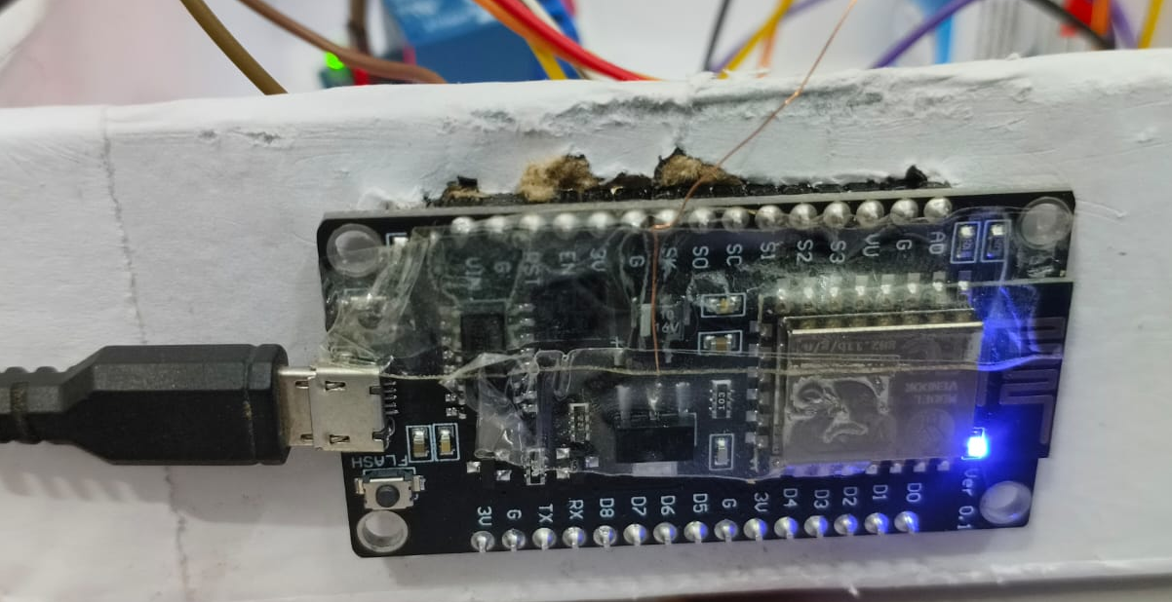

Figure 1 : NodeMCU Board

- Ultrasonic Sensor (HC-SR04):
The HC-SR04 sensor measures the distance between itself and the water surface using ultrasonic waves.
It sends a sound pulse and measures the echo time to calculate distance accurately.
Used here to measure real-time water level in the tank.

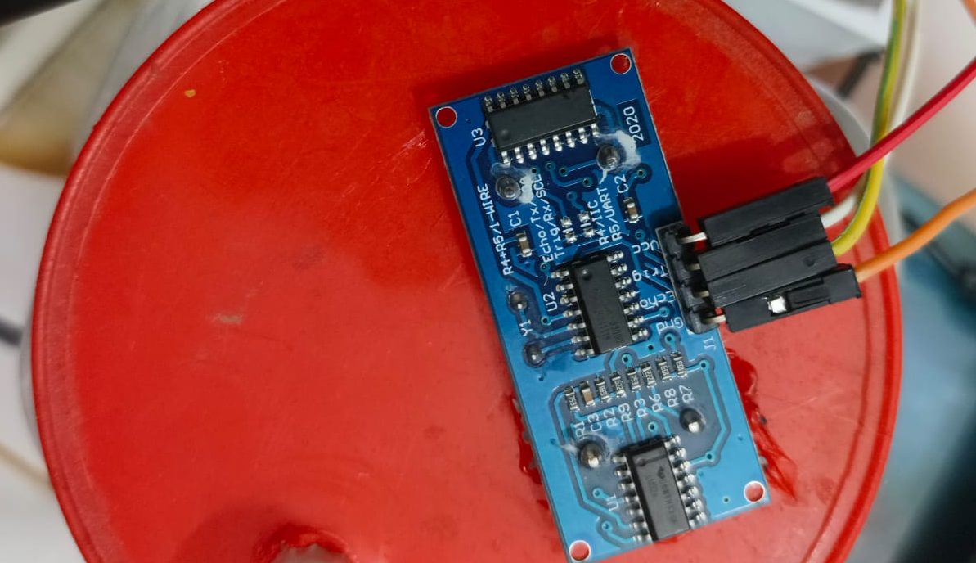

Figure 2: Ultrasonic Sensor (HC-SR04)

- 5V Relay Module:
The relay module works as an electrical switch.
It receives signals from ESP8266 and turns the pump ON or OFF based on water level.
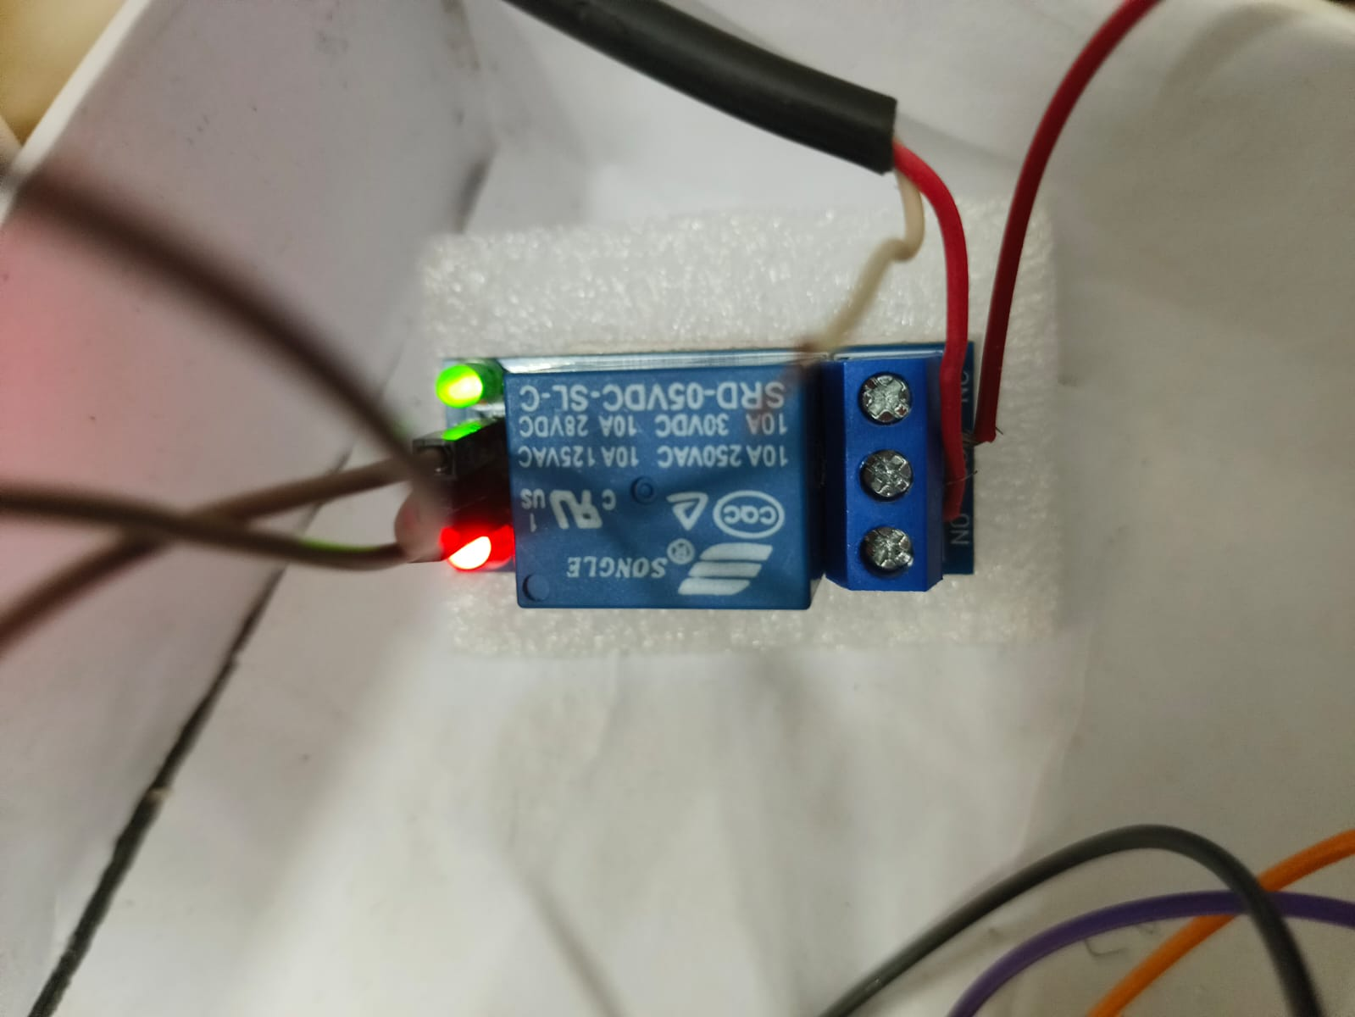
Figure 3: 5V Relay Module

- DC Water Pump:
A low-voltage pump used to fill the storage tank.
Relay controls the pump to avoid overflow.
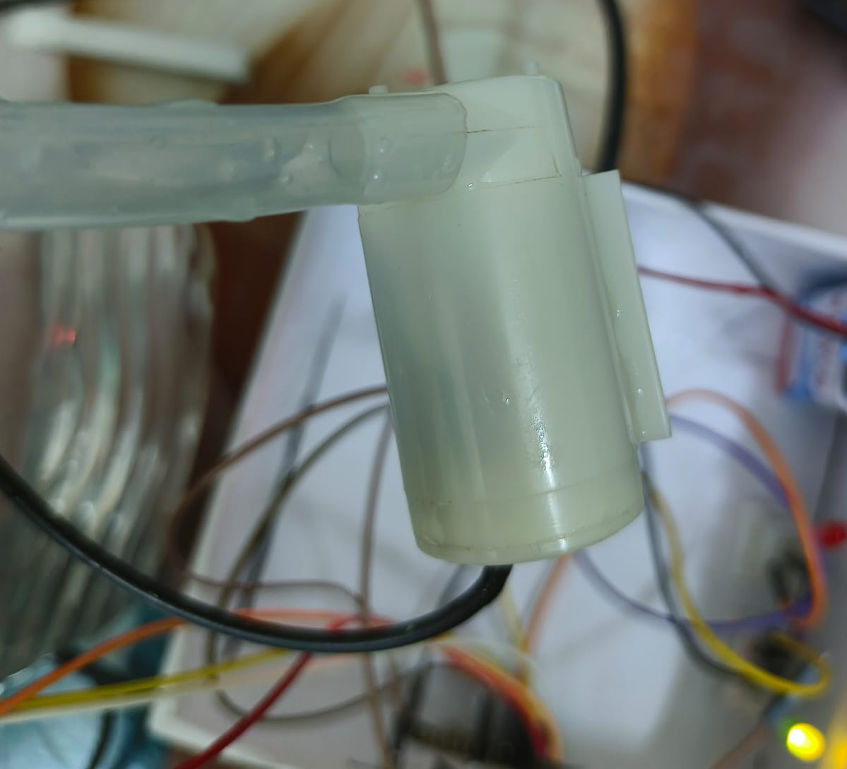
Figure 4: DC Water Pump

- 9V Battery:
Used as the power supply for the microcontroller circuit.
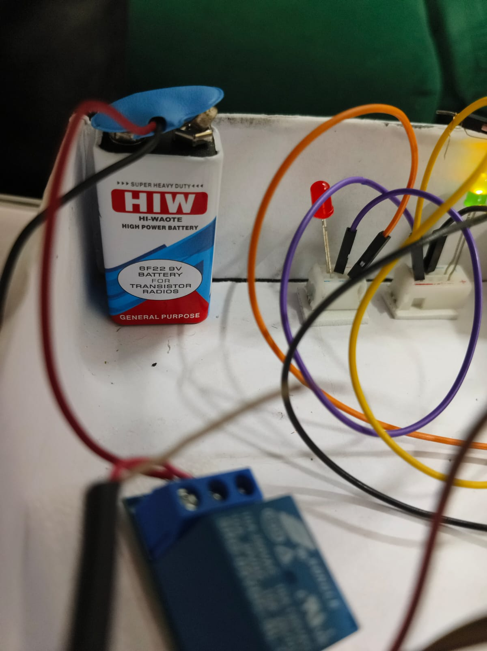
Figure 5: 9V Battery

- LED (Light Emitting Diode):
The LED (Light Emitting Diode) is a semiconductor device that emits light when an electric current passes through it. LEDs are widely used in electronic circuits as indicators, status signals, or visual notifications.
Uses in this Project:
- Indicates when the system is powered
- Provides visual feedback when the water motor or relay is activated
- Helpful for debugging and verifying code execution

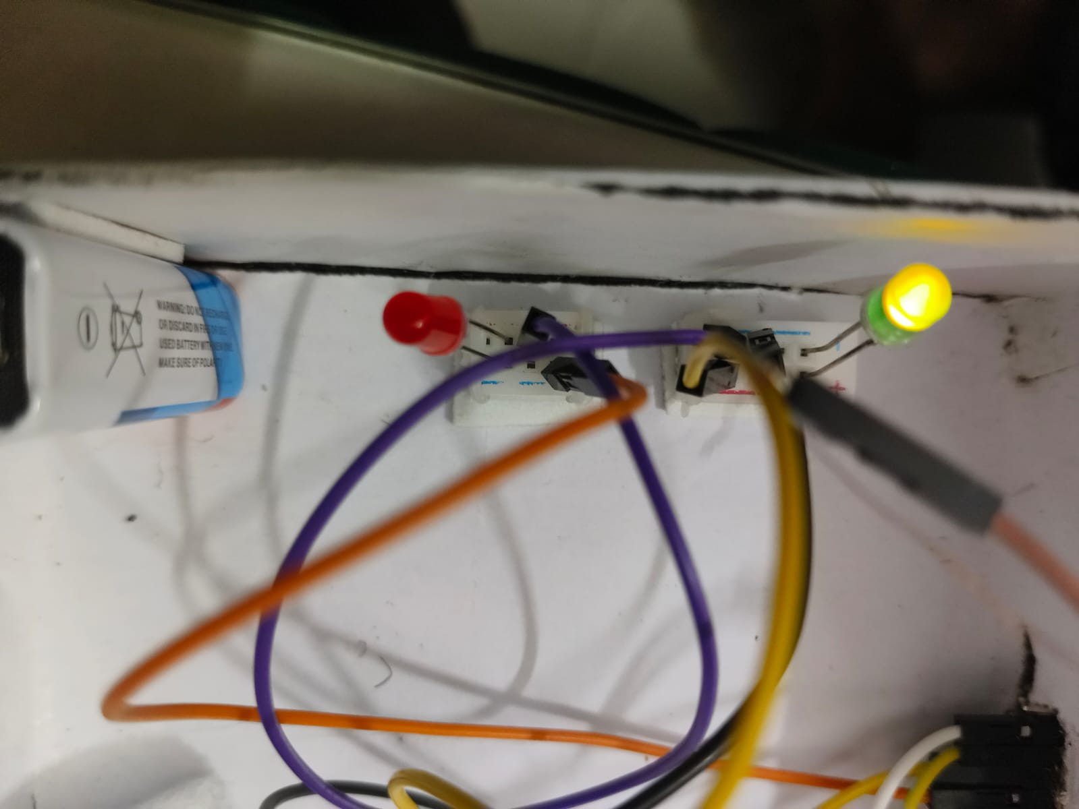
- Figure 6: LED

Block Diagram of Designed Model:
- The Ultrasonic Sensor measures the water level inside the tank.
- The measured distance is sent to the ESP8266 NodeMCU, which processes the reading.
- The controller decides whether the pump should be turned ON or OFF.
- The relay acts as a switch between the ESP8266 and DC water pump.
- The DC pump fills the tank when water is low.
- The 9V battery powers the system.
- The LED gives a visual indication of system activity (e.g., pump ON/OFF status).
Thus, the system ensures automatic water control without human intervention.
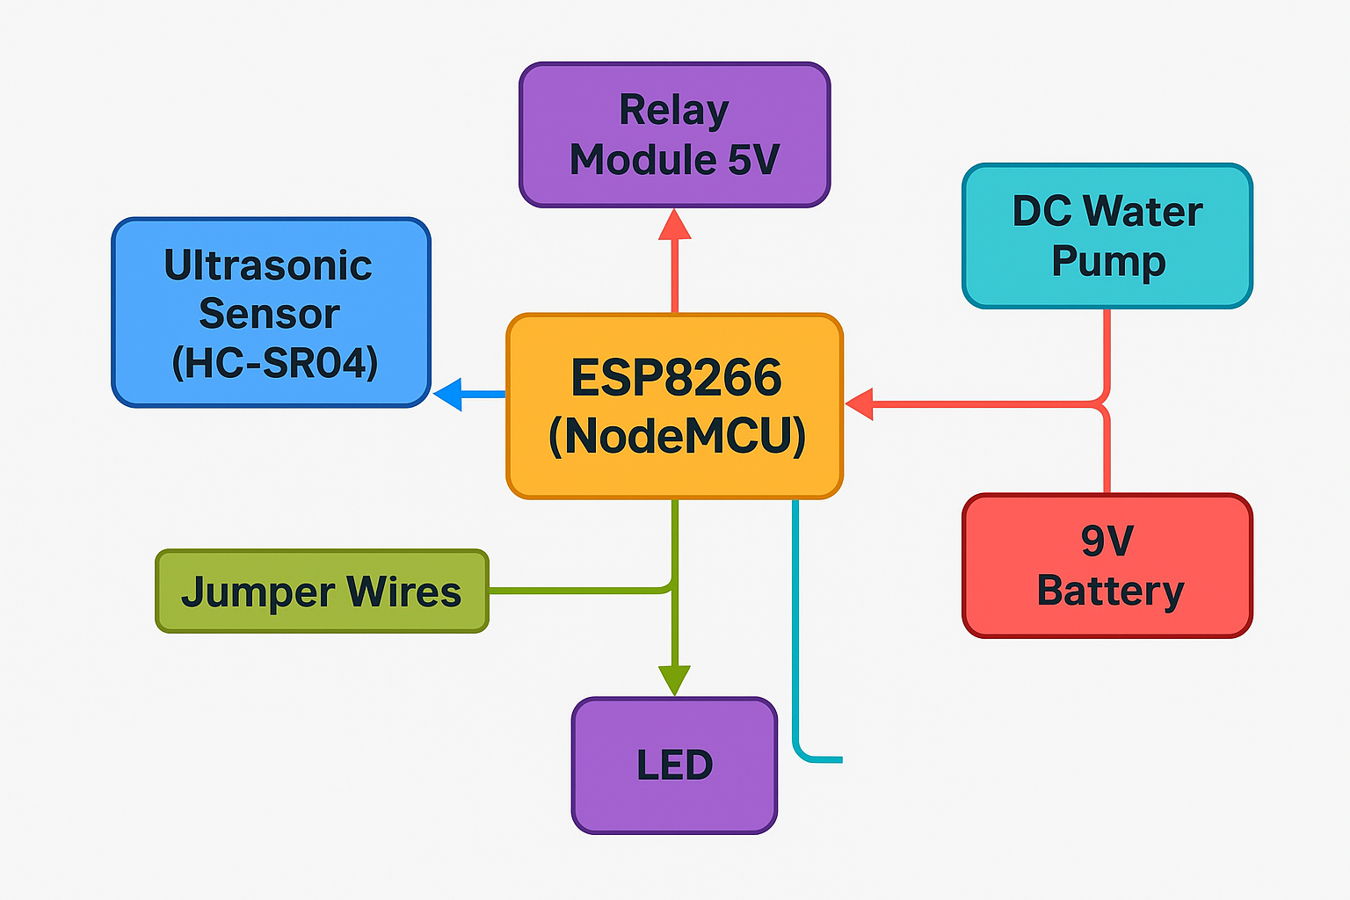
Figure 7: Block Diagram of Model

Working of Designed Model:

As shown in the block diagram, the ultrasonic sensor continuously monitors the water height.
The ESP8266 compares the measured distance with the set threshold:
- If the water level is LOW → Relay turns ON → Pump starts filling the tank.
- If the water level is HIGH (Full) → Relay turns OFF → Pump stops.
This ensures:

1. No human involvement
2. No water overflow
3. Prevention of pump dry-running
4. Efficient tank management
Pictures of Prototype:
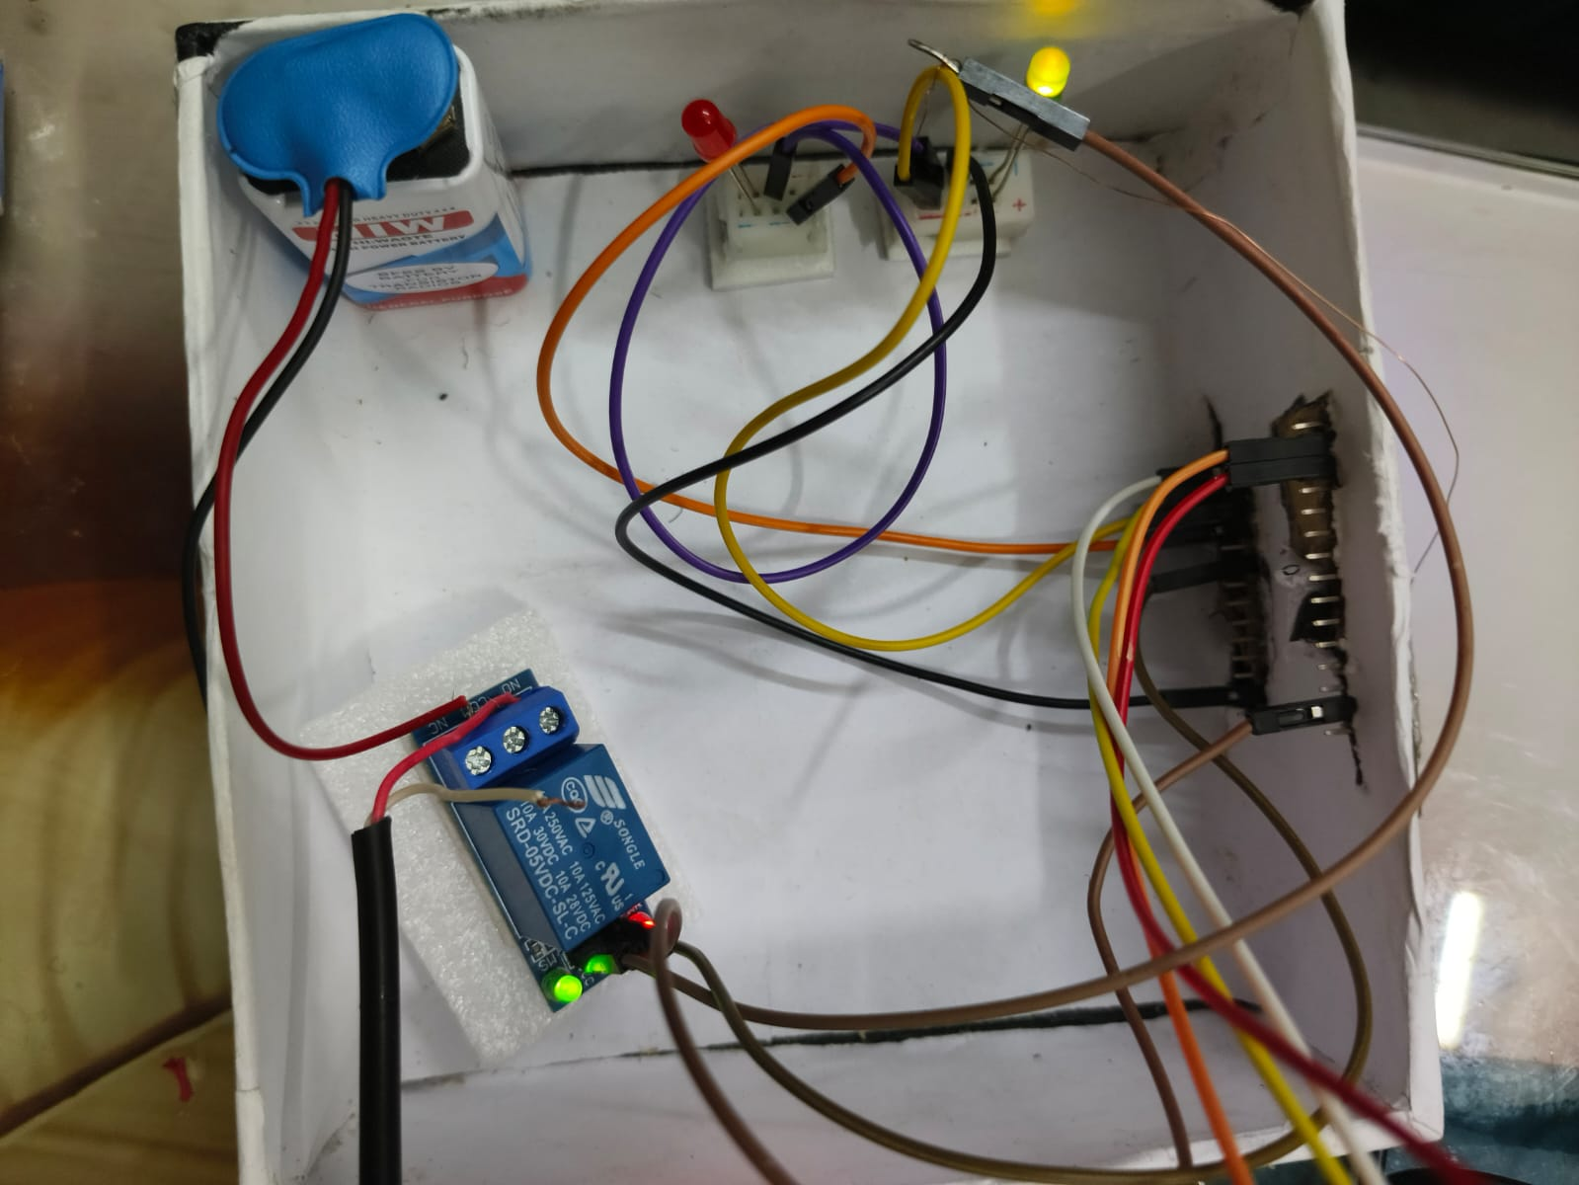
Figure 8: Designed Model

Output of Deigned Model/Prototype :

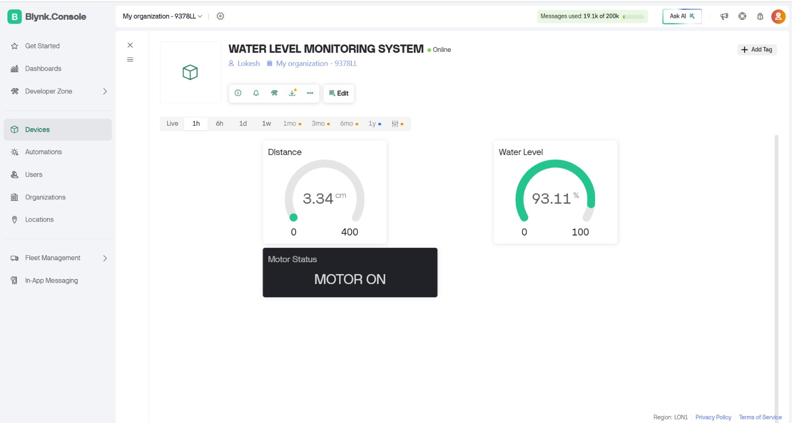
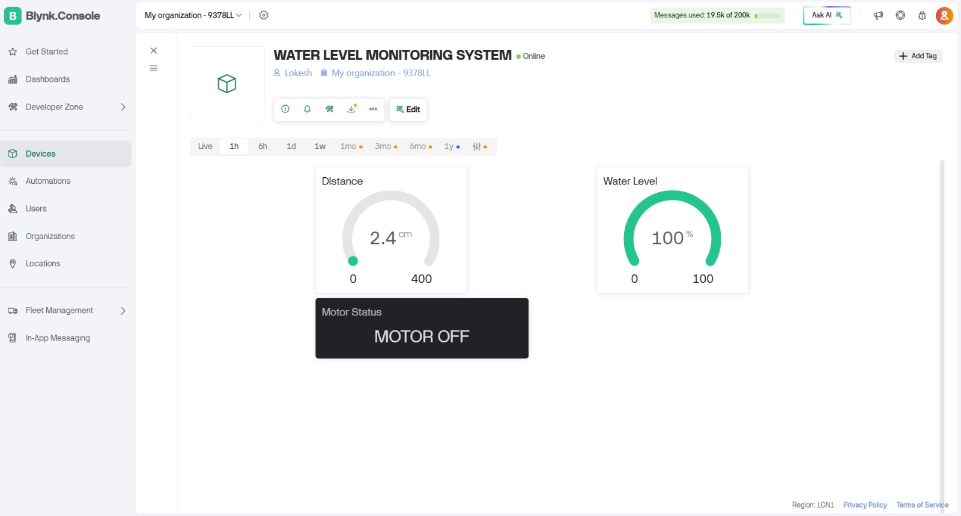

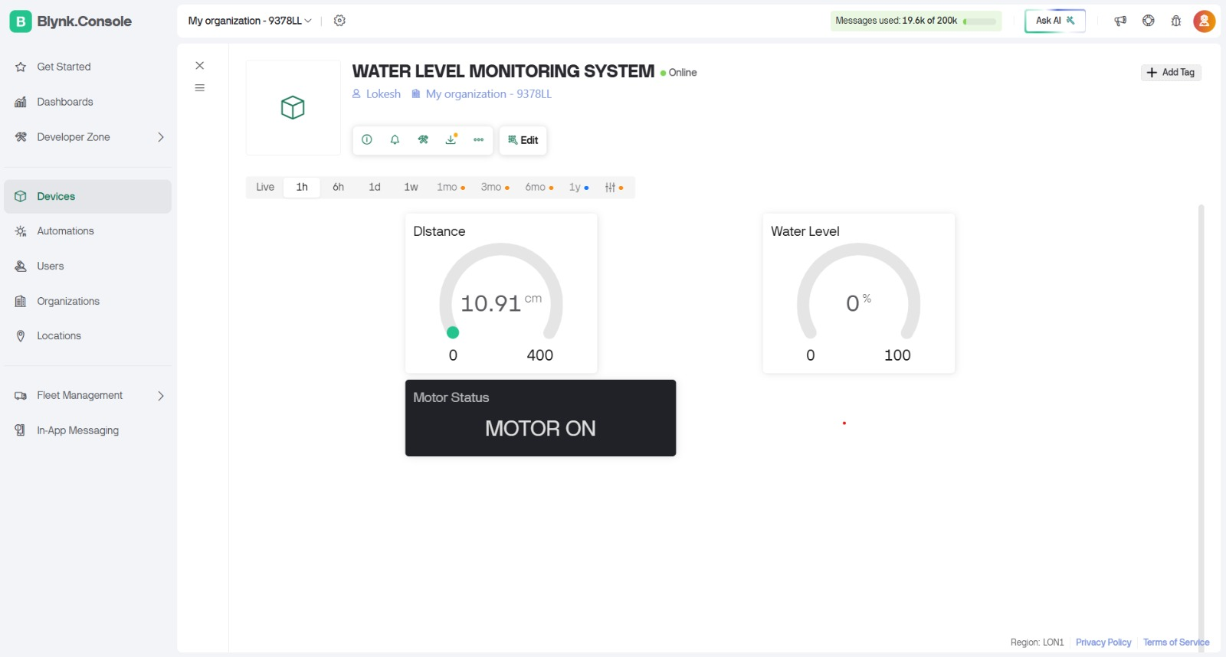

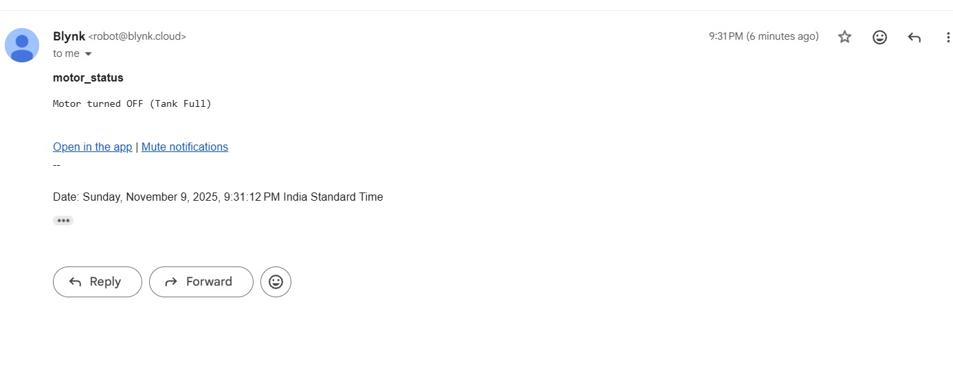

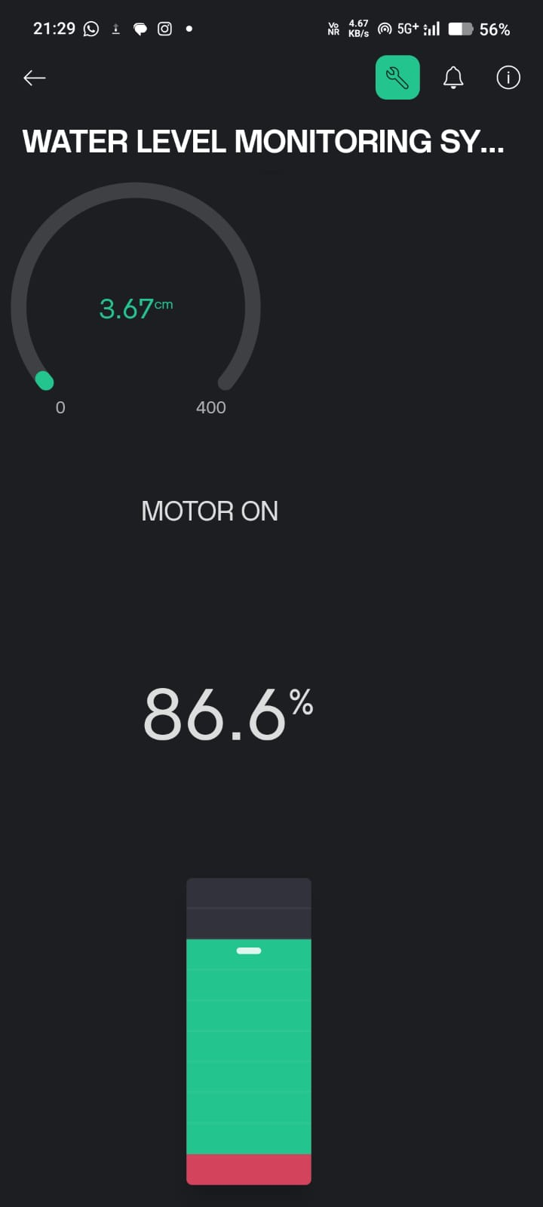

Figure 8 : Output on BLYNK Cloud

Learning outcomes (What I have learnt):

1. I learned how to interface ESP8266 with ultrasonic sensors.
2. I understood the working and control of relay modules.
3. I learned how to automate a process using microcontrollers.
4. I gained knowledge about IoT-based water level control systems.
5. I understood the practical implementation of real-time monitoring.

